**CCS-3085 - Digital Image Processing**

**Lab 4**

**Third Semester 2023**

## Grade

**Name, Family Name: omer khan**

**ID: 391007603 Section: 2242**

# Experiment No.8 Generate 10,000 Random Numbers and Create a Histogram.

x = randn(10000,1); h = histogram(x)

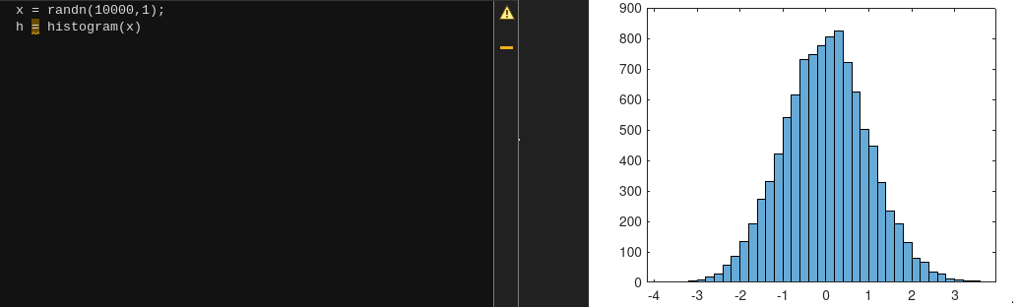

# Experiment No.9 Plot a Histogram of 1,000 Random Numbers Sorted Into 25 Equally Spaced Bins.

x = randn(1000,1); nbins = 25;

h = histogram(x,nbins);

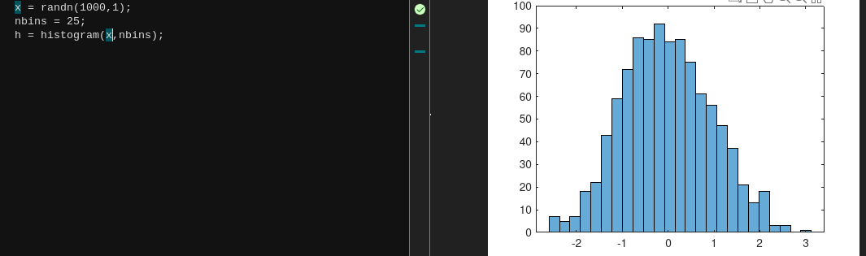

# Experiment No.10 Generate 1,000 Random Numbers and Create a Histogram Using the 'Probability' Normalization.

x = randn(1000,1);

h = histogram(x,'Normalization','probability')

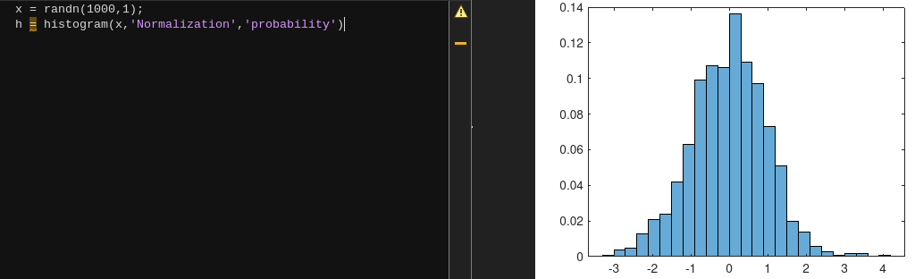

# Experiment No.11 Generate Two Vectors of Random Numbers and Plot a Histogram for Each Vector in the Same Figure.

x = randn(2000,1);

y = 1 + randn(5000,1); h1 = histogram(x); hold on

h2 = histogram(y);

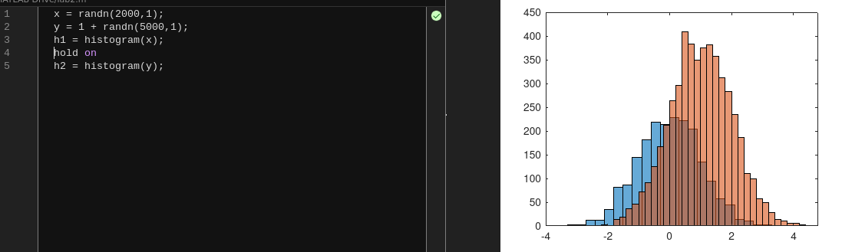

# Experiment No.12 Generate 1,000 Random Numbers and Create a Histogram. Return the Histogram Object to Adjust the Properties of the Histogram Without Recreating the Entire Plot.

x = randn(1000,1); h = histogram(x); h.NumBins = 4;

h.BinEdges = [-3:3];

h.FaceColor = [0 0.5 0.5]; %bin color rgb h.EdgeColor = 'r'; % edge color r = red

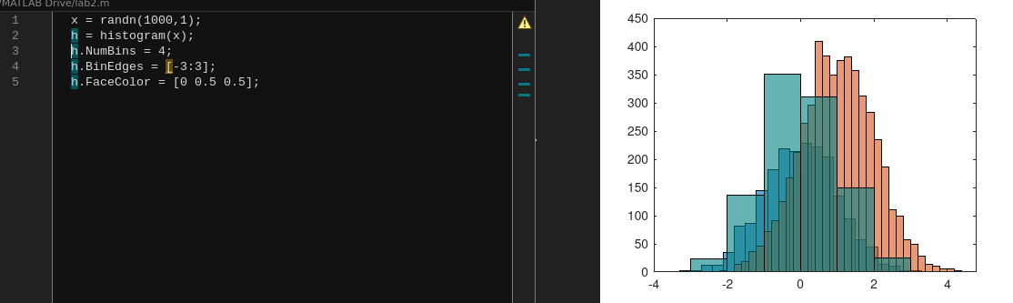

# Experiment No.13 Draw Histogram from an image.

img = imread('at.jpg'); histogram(img);

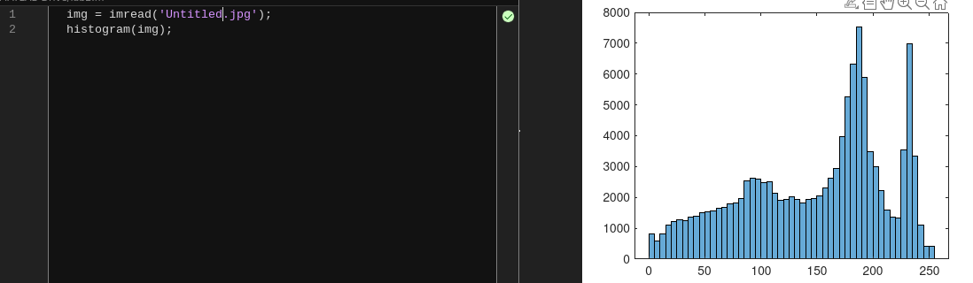

## Task:

* Read an image.
* Apply histogram equalization.
* Display original image, enhanced image, and their histograms in the same figure.
* 